**Spatio-temporal prediction of epidemics through fusion of information from diverse sources**

# Problem Description

Predicting the spread of epidemics through space and time can help government agencies and organizations better prepare and allocate resources. Seasonal flu epidemics have been closely monitored, and many years of historical data have been collected by the medical community. The data collected and aggregated by CDC has been valuable for researchers trying to develop models to forecast the spread of flu epidemics. In addition to the CDC data, there are many other data collected by different entities for various purposes – many of them unrelated to flu epidemics. When those datasets are considered together with the CDC data, they offer the opportunity to significantly improve our ability to assess and forecast flu epidemics both spatially and temporally. Such data include weather data, social network data, vaccination statistics, and flu medication sales. Those data have different characteristics (e.g. percentages for CDC regional ILI rates and flu vaccination, and quantized flu activity levels for CDC state ILI rates) and different spatial and temporal resolution. Aggregating the data into a forecasting model is challenging but, if successful, can provide much improved forecasting accuracy over a longer time horizon than what current approaches based on limited sources of information can accomplish.

## Phase 1 Problem

During Phase 1, the goal is to estimate Influenza-like Illness (ILI) rates at a spatial resolution finer than that of the ILI data from CDC. Performers can use all of the datasets listed in the next section, except for the NREVSS dataset (Phase 2 data), to estimate weekly ILI rates in the 48 contiguous states. The spatial resolution of the estimate should be at the county level. The results will be compared to state ILI rates from selected states (Maryland, North Carolina, Rhode Island and Texas) and district ILI rates from 2 states (Mississippi and Tennessee), where each district consists of multiple counties. The development in the first phase also helps to identify important covariates and their contributions to spatio-temporal interpolation and prediction.

The datasets cover the flu seasons 2013-2014 and 2014-2015. Performers can use all or some of the datasets for their development. The public set consists of data from the 2013-2014 flu season. The 2014-2015 flu season data will be used as the private set for evaluation. All of the 2014-2015 Phase 1 data except for the state and district level ILI rates from the selected states are available as input to the models. Fitted models will be evaluated based on their estimated state and district ILI rates against the actual ILI rates of the select states and districts.

## Phase 2 Problem

During Phase 2, the goal is to produce estimates ILI rates that are more timely than those published by the CDC data (while maintaining finer spatial resolution finer than the CDC). The ILI data from CDC and states have 1 to 2 weeks of delay. The models developed by the performers will be used to nowcast the weekly state and district ILI rates of the select states. The nowcast results will be compared to the released data from CDC and select states. Performers can also use the NREVSS dataset in this phase, which may provide additional predictive power.

All of the 2013-2015 data are available to performers in the public set. Performers are to develop models for 2-week-ahead nowcasting of the select states’ and districts’ ILI rates. Input to the model can include all of the data with 2 weeks of delay except for the Twitter data, where the data from the current week can be used. In Phase 2, the evaluation will be conducted on the current 2015-2016 flu season. Performers are evaluated based on their nowcast state and district ILI rates against the actual ILI rates.

# Data Description

|  |
| --- |
| Main Datasets |
| CDC Seasonal ILI Rate (HHS Regions) |
| CDC reports the weekly number of Influenza-like Illness (ILI)[1] cases collected through the U.S. Outpatient Influenza-like Illness Surveillance Network (ILINet) with roughly 2 weeks’ delay. This is considered a highly authoritative source of influenza related information in the medical field. The publicly available dataset contains the percentages of weekly outpatient visits for ILI since 1997. The cases in each reporting period are also divided into 10 Health and Human Services (HHS) regions, where a region covers multiple states, and is partitioned into 5 age groups. |
| CDC Seasonal Flu Activity Level (States) |
| CDC also publishes a weekly measure of flu activity for each state. The flu activity is quantized into 10 levels. “The 10 activity levels correspond to the number of standard deviations below, at or above the mean for the current week compared to the mean of the non-influenza weeks. … An activity level of 1 corresponds to values that are below the mean, level 2 corresponds to an ILI percentage less than 1 standard deviation above the mean, level 3 corresponds to ILI more than 1, but less than 2 standard deviations above the mean, and so on, with an activity level of 10 corresponding to ILI 8 or more standard deviations above the mean.” |
| State and County ILI Rates (Selected states and counties) |
| This dataset contains percentages of ILI cases from Massachusetts, North Carolina, Rhode Island and Texas for the 2012-2013, 2013-2014, and 2014-2015 flu seasons. For Mississippi and Tennessee, percentages of ILI cases are also broken out by districts/regions. Mississippi is divided into 9 districts and Tennessee into 13 regions, where each district/region consists of multiple counties. However, some districts/regions in some weeks have missing ILI data. |
| Twitter Data |
| The dataset contains the number of flu related tweets without re-tweets and not from the same user within the syndrome elapsed time of 1 week. The flu related tweets are defined as tweets with keywords “flu,” and “influenza.” The locations of the tweets provides observations with finer spatial and temporal resolution than CDC data, but the data are very noisy. |
| Flu Vaccination Data of Medicare Recipients |
| As people receive flu vaccines, the percentage of population susceptible to flu is reduced, and even when vaccinated people get the flu, they generally have milder symptoms. This reduces the number of reported ILI cases. Hence, the flu vaccination data may have strong predictive power for future ILI cases. This dataset contains weekly cumulative percentages of Medicare recipients filing flu vaccination claims of each year between 2012 and 2015 for each county in the United States. It is noted that the data covers only Medicare recipients, and the majority of the recipients are age 65 or older. |
| NREVSS: The National Respiratory and Enteric Virus Surveillance System (Phase 2) |
| In addition to the ILINet data, CDC also aggregates to HHS regions the weekly percentage and number of respiratory specimens tested positive for influenza and the weekly number of cases for each influenza virus type. Since illness due to Type A and Type B flu virus may peak at different time during the flu season, using this dataset may improve prediction of ILI rates. |
|  |
| Supporting Data |
| Twitter User Demographics |
| To account for the demographic differences of Twitter users from the general population, we will use data from a study by Pew Research, that summarizes the demographics of Twitter users by gender, race, education, and income level. The demographic information may help to correct some Twitter sampling bias by normalizing the tweet counts based on the demographics of their corresponding local populations. |
| US Census |
| Total population and percentages of population by age group, education and income level of each county in the United States. |
| County Adjacency Data |
| The file contains state association of each county and its neighboring counties. |

# Baseline Spatio-temporal Model

The baseline Bayesian hierarchical model captures various effects commonly present in temporally and geographically referenced data. The baseline model attempts to describe both spatial clustering and temporal correlations. For effects that are caused by known factors, the model also incorporates the fixed-effects term to capture their influence on the observations, in addition to the spatial and temporal random effects. The model has been developed with computational concerns in mind. The use of Gaussian Markov Random Field (GMRF) in modeling the random effects allows this approach to take full advantage of the spatial and temporal correlations while still maintaining manageable memory usage. The specific model structure is below:

|  |  |
| --- | --- |
| County ILI Rate Model | $$log\left(\frac{z_{c,t}+ϵ_{1}}{{1-z}_{c,t}+ϵ_{1}}\right)=β^{T}X_{c,t}+y_{c,t}+n_{c,t}$$*c*: county index; *t*: week index $X_{c,t}$ : covariates for each county $c$ and week $t$ $y_{c,t}$: spatio-temporal correlation of ILI $-∞<y_{c,t}<+∞$ (see below) $z_{c,t}$ : ILI rate (between 0 and 1) of county *c* in week *t $n_{c,t}$*  : zero-mean Gaussian noise (see below) $ϵ_{1}=0.0001$ : a small number to ensure numerical stability |
| Aggregate Observations | $$z_{R_{i},t}=\sum_{c∈R_{i}}{\left(\frac{N_{c}}{N_{R_{i}}}\right)}z_{c,t}$$ ${ R}_{i}$: set of counties in area $i$; the area can be a HHS Region, a state or a district in a state $z_{R_{i},t}$ : reported ILI rate of HHS Region *i* in week *t $N_{c}$*  : population of county c $N_{R_{i}}$ : population of region *i* |
| Spatio-temporal correlation | $$p(Y)∝\exp\left(-\frac{1}{2}τ_{1}Y^{T}(D_{w}-W) Y\right)$$ $$Y={\left[\begin{matrix}y_{1,0} & y_{2,0}\end{matrix} … \begin{matrix}y_{1,1} & y_{2,1}\end{matrix} … \begin{matrix}y_{C,T-1} & y_{C,T}\end{matrix}\right]}^{T}$$ $$C:\text{ total number of counties; }T:\text{ total number of weeks}$$ $$D_{w}:\text{ diagonal matrix; }W:\text{ sparse symmetric matrix }$$ The elements of *W* are defined as $$\left\{\begin{matrix}\begin{matrix}w_{\left(c,t\right)\left(c,j\right)}=ρ & where j=t-1 or t+1, \\ w_{\left(c,t\right)\left(i,t\right)}=1 & if i \text{ is a neighboring county of }c, \\ w_{\left(c,t\right)\left(i,j\right)}=0 & \text{otherwise},\end{matrix} & \end{matrix}\right.$$ where the subscript (*c, t*) (*i, j*) denotes the row and column indices of the element of *W* that corresponds to $y_{c,t}$ and $y_{i,j}$ in *Y*. It is noted that *W* is a very large but very sparse matrix. However, the only non-zero entries of *W* are those whose row and column indices correspond to pairs of elements in *Y* that represent the effects of neighboring counties from the same week or of the same county from consecutive weeks. Hence, it is recommended using a sparse matrix formulation for *W* and similarly for *Dw*  : precision (inverse variance) that controls the spatio-temporal correlations (smoothness) of ILI rates |
| Covariates | $$X_{c,t}={\left[\begin{matrix}\log\left(\frac{S_{c,t}+ϵ_{2}}{{\tilde{N}}_{c}}\right), & \log\left(\frac{V_{c,t}+ϵ_{3}}{1-V_{c,t}+ϵ_{3}}\right)\end{matrix}\right]}^{T}$$ $S_{c,t}$: number of flu-related tweets from county *c* in week *t*. $V_{c,t}$ : cumulative percentage of Medicare recipients filing flu vaccination claims from county *c* in week *t*. ${\tilde{N}}_{c}=Σ_{g}N_{c,g}U_{g}$ : Twitter user demographics adjusted population of county *c $N_{c,g}$*  : population of county c belonging to age group *g*. $U_{g}$ : percentage of Twitter users belonging to age group *g*. $$ϵ_{2}=0.1, { ϵ}_{3}=0.001$$ |
| County heterogeneity | $$n_{c,t} \sim ^{iid} N(0, 1/{τ_{2} )}$$ |
| Hyperprior | $β_{1}$ ~ *N*(0,10), $β_{2}$ ~ *N*(0,10) $τ_{1}$ ~ *G*(3, 0.1), Gamma distribution ( (shape),  (rate) definition) $τ_{2}$ ~ *G*(10, 0.1) $ρ$ ~ G(1.05, 0.5) |
|  |  |

We can visualize the model as follows where we assume that the counties are located on a grid for illustration purpose. The GMRF defines a time series of latent prevalence maps:

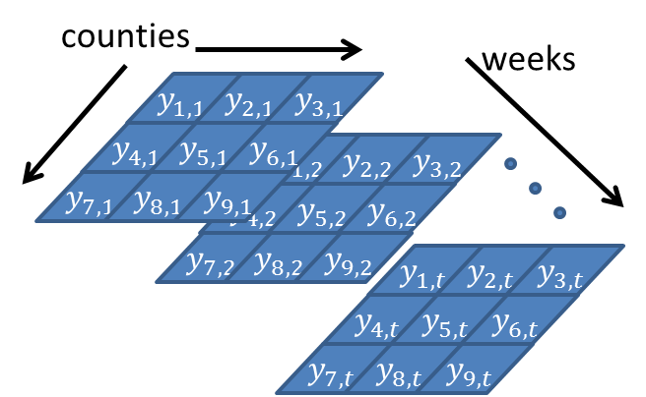

Each cell is connected to its neighbors in time and space. The adjacency matrix W contains a 1 for spatial neighbors and $ρ$ for temporal neighbors.

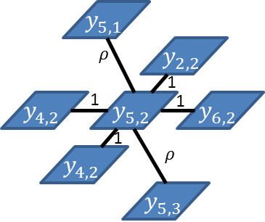

The latent prevalence is combined with covariates and a noise term to generate the observations:

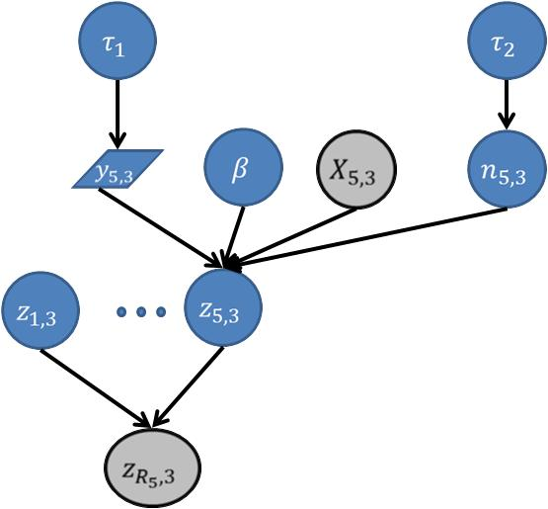

Grey variables are observed at training time. Only $X$ is observed at prediction time. Note that typically several individual county prevalences ($z_{1,3},…,z_{5,3}$) are aggregated to produce the observed value.

# Queries

1. **Reconstruction.** Given weekly $S_{c,t}$ (number of flu related tweets) and $V_{c,t}$ (cumulative percentage of Medicare flu vaccination claims) of every county and weekly $z_{R_{i},t}$ (ILI rates) of every HHS region, output a marginal MAP and MAP estimates for weekly ILI rates $z_{R_{D},t}$ of individual counties in the selected states (Tennessee, Mississippi, Massachusetts, North Carolina, Rhode Island and Texas).
2. **Prediction.** Given weekly $S_{c,t}$ (number of flu related tweets) and $V_{c,t}$ (cumulative percentage of Medicare flu vaccination claims) of every county for weeks $t=1,…,u$ and weekly $z_{R_{i},t}$ (ILI rates) of every HHS region for weeks $t=1,…, u -1$, output a marginal MAP and MAP estimates for weekly ILI rates $z_{R_{D},u}$ of individual counties in the selected states (Tennessee, Mississippi, Massachusetts, North Carolina, Rhode Island and Texas).

# Evaluation Metrics

1. **Population-adjusted Squared Error.** Let ${\hat{z}}_{c,t}$ be the predicted prevalence for county $c$ at time $t$; let $R_{i}$ be a region that contains county $c$; let $z_{R_{i},t}$ be the observed prevalence in region $R_{i}$; and let $N_{c}$ be the population in count $c$. A region in this case is the smallest geographical area where ILI truth data is available. Define ${\hat{z}}_{R_{i},t}$ to be the aggregated prevalence (weighted by relative population):

$${\hat{z}}_{R_{i},t}=\frac{\sum_{c∈R_{i}}{N_{c}{\hat{z}}_{c,t}}}{\sum_{c∈R_{i}}{N_{c}}}.$$

Then the loss is

$$\sum_{i}{N_{R_{i}}\sum_{t}{{\left({\hat{z}}_{R_{i},t}-z_{R_{i},t}\right)}^{2}}}$$

1. **Start and Max of the epidemic**. Let ${\overline{M}}_{R_{i}}$ be the week in which the highest prevalence was observed during the year. Let $S_{R_{i}}$ be the week when the prevalence first exceeded 5%. We will compute the absolute difference between the observed and predicted values of these quantities.

# Input and Output Data Formats

**Input 1 (Flu_Vacc_Tweet.json): $S_{c,t}$ (**number of flu-related tweets) **and $V_{c,t}$ (**cumulative percentage of Medicare recipients) stored in a **JSON** file. The name of each object is the 5-digit FIPS code of a county (or equivalent), which uniquely denotes a county (e.g. 01001 is Autauga County, AL), and its value is relevant information associated with the county including $S_{c,t}$**, $V_{c,t}$**  and demographics.



**Input 2 (Flu_ILI.csv):** Weekly $z_{R_{i},t}$ (ILI rates) of HHS Regions, states and districts in CSV. If no data is available, NaN is given.



**Output 1:** Weekly $z_{R_{i},t}$ (ILI rates) of individual counties in a JSON file.The name of each object is the 5-digit FIPS code of a county, and its value contains its weekly ILI rates and in the time frame of interest:



**Supporting Information (StateInfo.json)**: a JSON file that provides all of the counties in each state.



1. “ILI is defined as fever (temperature of 100°F [37.8°C] or greater) and a cough and/or a sore throat without a KNOWN cause other than influenza.”